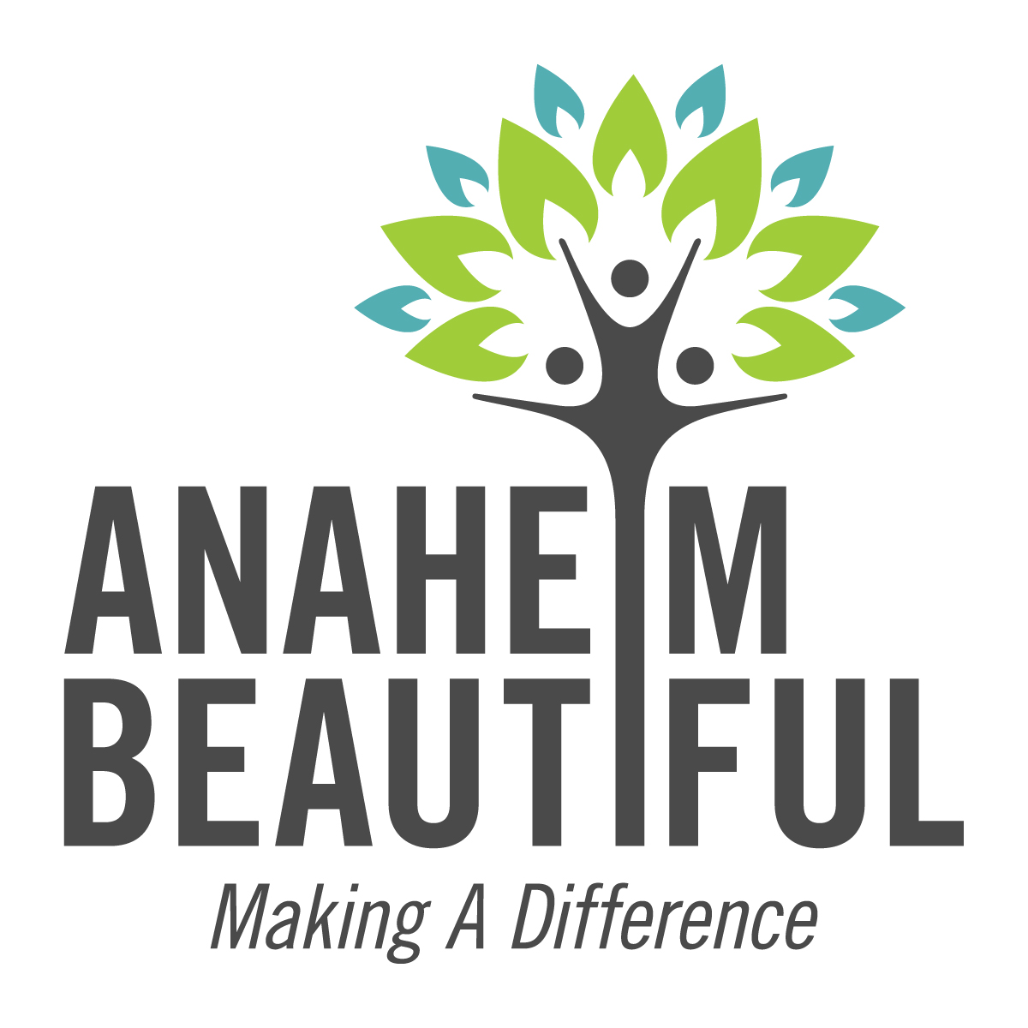
Contact: Mark Dickinson
contact@anaheimbeautiful.org
714.765.5158

FOR IMMEDIATE RELEASE

ANAHEIM, CA – March 28, 2019 - Anaheim Beautiful wants to remind parents throughout the city that elementary students enrolled in all Anaheim school districts have the opportunity to participate in the Anaheim Beautiful Community Pride Poster Contest. The deadline for all posters to be submitted at the school level is Friday, April 26th. The contest is a community partnership that includes the City of Anaheim Department of Public Works, Code Enforcement Division, Superior, and Republic Services.
Community Pride is a contest offered to all public schools in Anaheim for students, 1st through 6th grade. Students are invited to create a poster on one of the following Community Pride themes: Recycling, Graffiti-Free, Litter-Free. The mission is to promote and bring awareness to anti-littering, anti-graffiti and recycling, as well as educate students on the importance of keeping Anaheim and the Earth Beautiful. Community Pride Contest winners will be announced on, June 4, 2019. The winning artwork will be displayed on the Anaheim Beautiful website and The City of Anaheim’s Public Works recycling page.
Contest Overview - There are three levels to the Anaheim Community Pride Poster Contest: School, District and City level. All participating schools will receive free poster templates for students to submit their entries. Certificates will be given to the first, second and third place winners at the school level (per grade level). District winners will receive a certificate and a Community Pride hat. City
- cont -
level winners will receive various grand prizes! Please plan on joining us in person or on the local television channel for the presentation of the Community Pride Poster Contest City winners with the City of Anaheim’s Mayor and City Council at the June 4th meeting beginning at 5 pm.
The Anaheim Community Pride Poster Contest is sponsored by the Anaheim Public Works Department and Code Enforcement Division.
###

Anaheim Beautiful - Anaheim Beautiful was organized in 1970 by founding President Thelma Jordan. We are a non-profit organization composed of citizens and affiliated local organizations. Our mission is to initiate, encourage, promote and actively participate to preserve and enhance the beauty of Anaheim.

