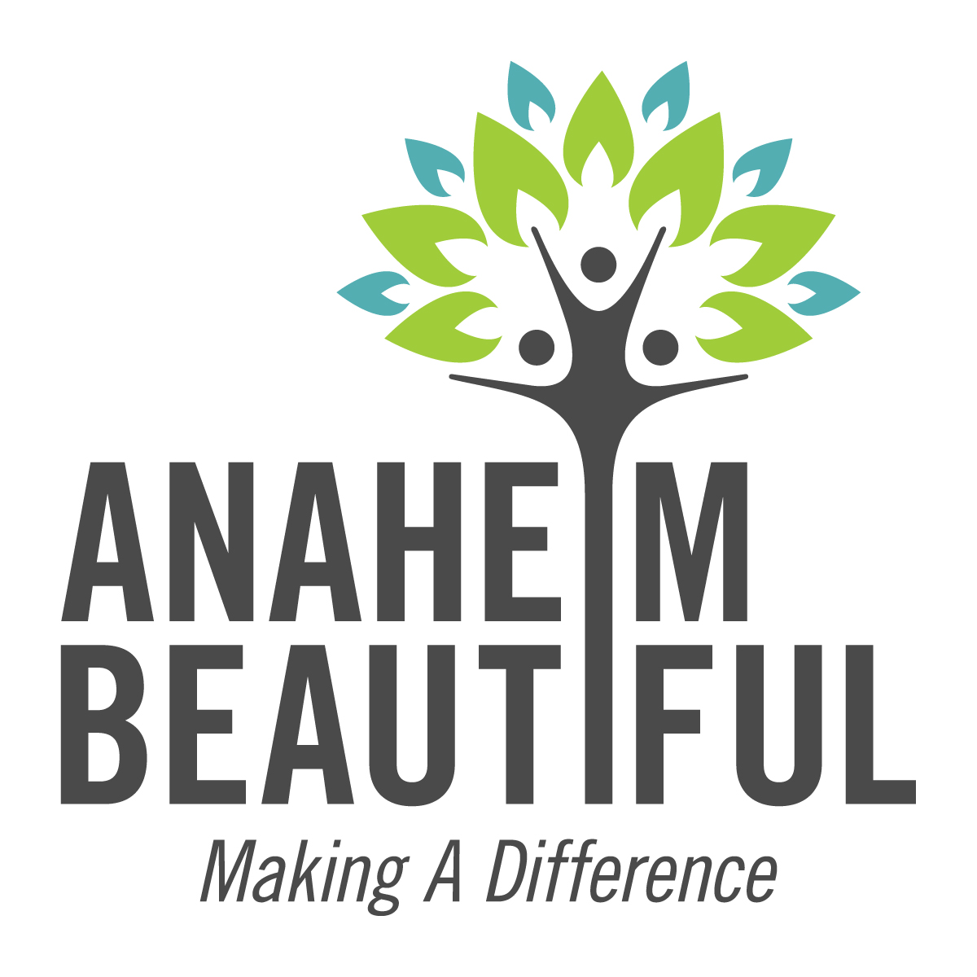
MEDIA ALERT

Who Anaheim Beautiful will be partnering with the Anaheim Rotary Club and the City of Anaheim once again with a local neighborhood clean up effort in the Balsam Curtis area in Anaheim. Superior Graffiti Removal Services, a long time member of Anaheim Beautiful, will also be on hand to remove any graffiti found in the neighborhood. Individuals and volunteer groups are welcome to join in the effort.

What The project is part of Anaheim Beautiful’s Adopt-A-Neighborhood program that began in 2009 in the Balsam Curtis area. Working with the residents, the event is designed to instill a sense of community pride and help make the area a safer, cleaner and more attractive place to live. Two cleanups were held last year and this will be the first in 2017.

Where The Balsam-Curtis Neighborhood in Anaheim is near the corner of State College, Romneya and Placentia. Volunteers arriving promptly at 9 am are asked to meet behind the Skecher’s store across the street. Those coming later can join in at the corner of Balsam and Curtis Streets. Residents are encouraged to join in the clean up effort.

When Saturday, April 29, 2017
Start Time: 9 am (Cleanup expected to last 2-3 hours)

Why In 2009, the Anaheim Rotary Club became the first of Anaheim Beautiful’s partners to make a commitment to the Adopt-A-Neighborhood program with their cleanup efforts in the Balsam-Curtis Neighborhood. This commitment continues what they started so many years ago with support to help the residents keep their neighborhood beautiful. The changes have had a permanent positive impact on the area.

Contact Steve Rosco, Anaheim Rotary Club
steve@steverosco.com or 714.743.4300
or Carol van Ahlers, Anaheim Beautiful Media Support
vannauss@gmail.com or 714.606.3620

For more information on Anaheim Beautiful: www.anaheimbeautiful.org

